Schulmerich TymeStrike Gen 4 DSP Carillon Reverse Engineering Notes

Fiber Optic Bridge Card

The FO bridge card uses two 2-channel UARTS that synchronously transcieves serial data encoded on FO TX and RX modules. The bridge provides 4 FO connections consisting of a TX and RX module for each, essentially a 4 port bidirectional repeater. The encoding is 38400, 8, N, 1. Data received by the bridge on one of the 4 RX retransmitted out the other TX modules. Data appears to be received by the UART, presented as parallel data to the microcontroller, and then enqueued for transmission after a short delay. The RX and TX operations overlap and appear to be cut through – with transmission following reception without additional pauses being inserted.

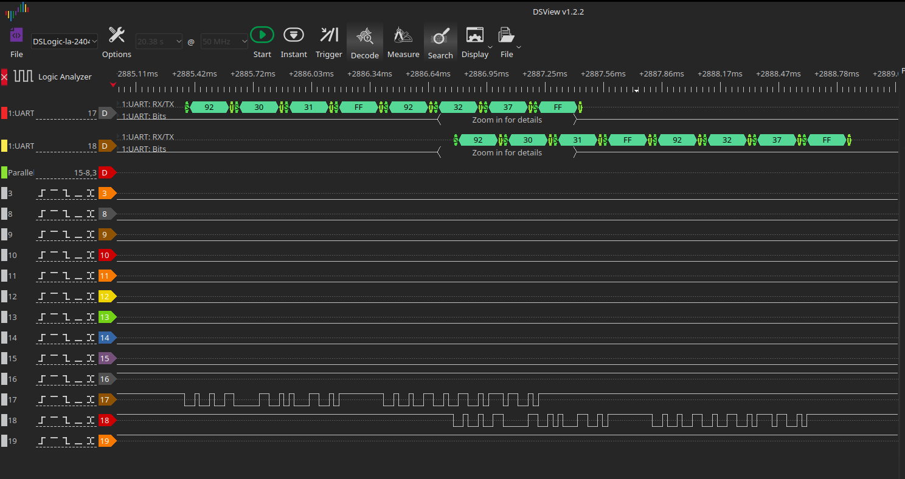
Typical RX ( ch 17 ) event from keyboard being repeated by the bridge card and sent out the TX ( ch 18 ) to the carillon control panel.

Keyboard FO Interface

Turning Keyboard “ON” via Lock Switch

Rotating the lock switch causes the Keyboard to emit F1 30 00 01 FF, the final FF is seen after most transmissions and seems to be a delimiter following MIDI data.

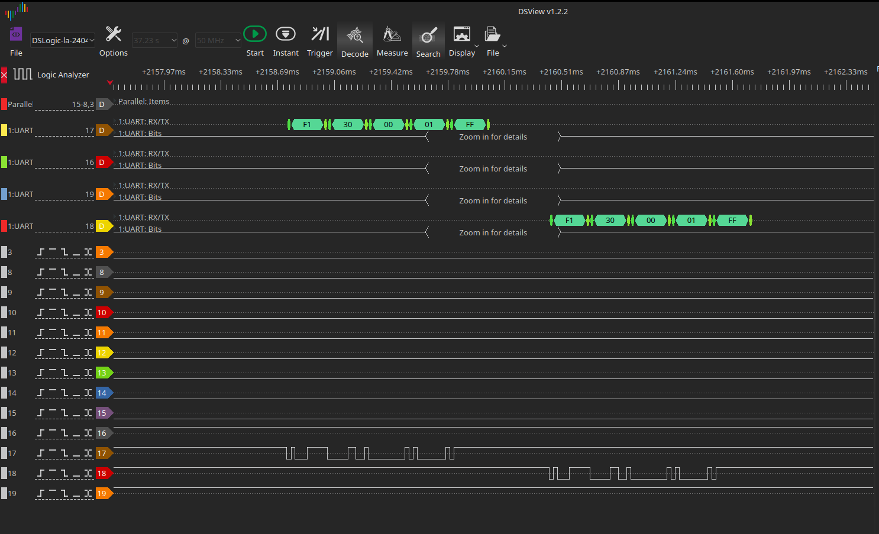
Immediately following, the parallel bus between the console and the DSP starts apparently transmitting data to the DSP board and additional data from the console is sent to the DSP and also back to the FO serial bus. Most of the serial chatter is directly seen to be FF delimited MIDI byte sequences. After the initial activation of the keyboard, two bursts of DSP bus + FIO activity are seen. Most seems to be initiated by the control panel. Once this interaction completes, playing notes on the keyboard result in straightforward Keyboard ==> Repeater ==> Console ==> DSP MIDI traffic.

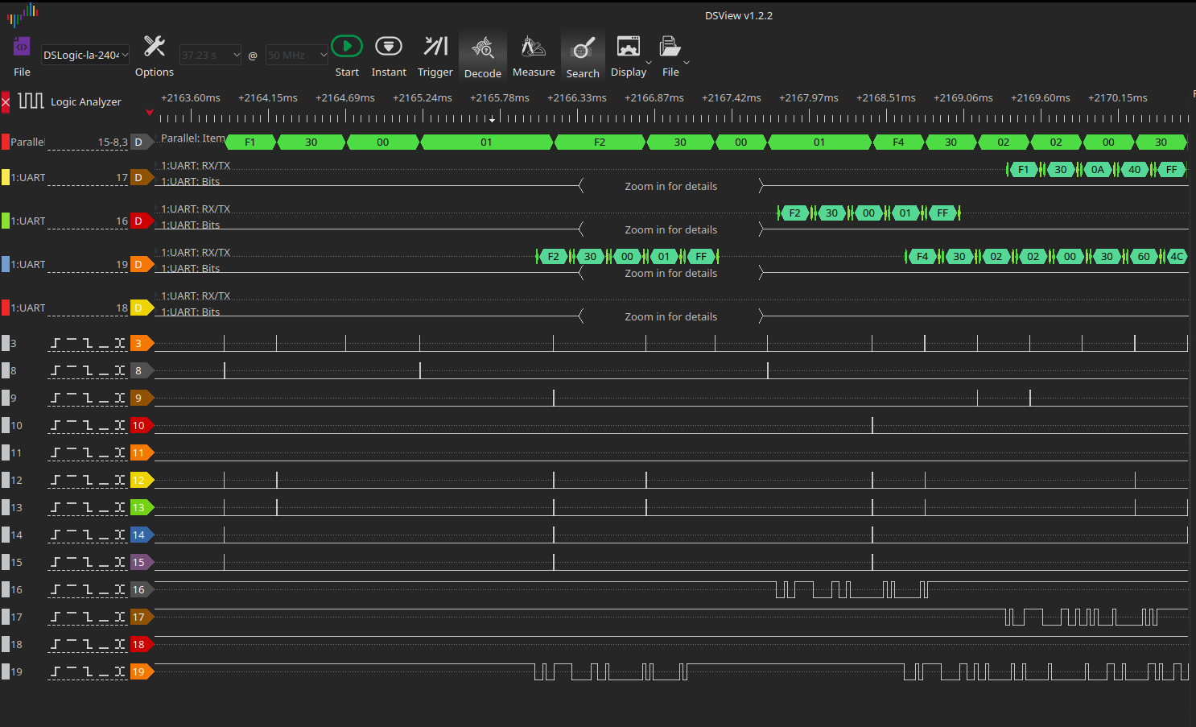
Playing the pre-recorded Claire de Lune …

Selecting collections and songs from the keyboard shows the keyboard initiating a short request, then the DSP parallel bus showing the text name of the collection / song. This is then sent to the keyboard via FIO. This suggests the DSP board actually “knows” this information.

